**Profile Locations Clew Bay.**

1. 53° 51. 000’N   9° 46. 500’W 🡪 53.850°N latitude and -9.775°W longitude
2. 53° 51. 000’N   9° 52. 000’W 🡪 53.850°N latitude, -9.867°W longitude
3. 53° 48. 000’N   9° 52. 000’W 🡪 53.800°N latitude, -9.867°W longitude
4. 53° 48. 000’N   9° 46. 500’W 🡪 53.800°N latitude, -9.775°W longitude

**Exo Sonde** 2/4/2024.

**Profile 1** Sonde deployed at 14.05.

Sonde recovered at 14.18.

**Profile 2** Sonde deployed at 14.29.

Sonde recovered at 14.34.

**Profile 3** Sonde deployed at 14.45.

Sonde recovered at 14.48.

**Profile 4** Sonde deployed at 15.01.

Sonde recovered at 15.04.

**Cloughcormac**:       53° 50. 467’N 9° 44. 865’W 🡪 53.841117°N latitude, -9.74775°W

Sonde deployed at 15.22.

Sonde recovered at 15.25.

**Eelgrass:**                53° 48. 635’N   9° 38. 366’W 🡪 53.810583°N latitude, -9.639433°W

Sonde deployed at 15.40.

Sonde recovered at 15.43.

**Blackshell:**               53° 52. 167’N   9° 38. 617’W 🡪 53.86945°N latitude, -9.643617°W

Sonde deployed at 16.00.

Sonde recovered at 16.02.

**Rosmore:**                 53° 52. 977’N   9° 36. 025’W 🡪 53.88295°N latitude, -9.600417°W

Sonde deployed at 16.10.

Sonde recovered at 16.12.

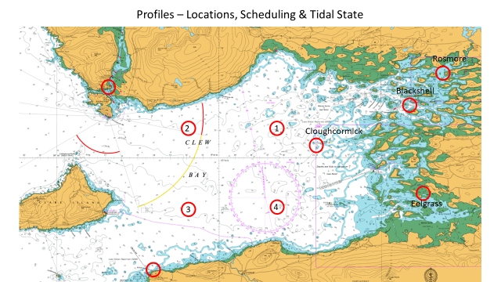

Map for aquaculture sites in Clew Bay (SFPA website)

